

**KULLIYYAH OF INFORMATION AND COMMUNICATION TECHNOLOGY**

**INFO 3305**

**WEB APPLICATION DEVELOPMENT**

**SEMESTER 1 2019/2020**

**SECTION 3**

FINAL PROJECT REPORT

AURORA CAT MANAGEMENT SYSTEM

Nur Syazwina Binti Ruhaizad 1717470

Supervised By:

Dr. Najhan Bin Muhamad Ibrahim

**Table of Content**

**1.** **PROJECT DESCRIPTION 3**

**2.** **METHODOLOGY 3**

**2.1. Analysis** **3**

**2.2.** **Development** **6**

**3.** **CONCLUSION 12**

**REFERENCES** **12**

**APPENDIX 13**

1. **Project Description**

This project is basically about the system that manage the rescue shelter to help the stray cats in IIUM. One of the main purpose is I want to build a system that can manage the rescue shelter for IIUM stray cats with the objectives to rescue, treat (if needed), neutered and find adopters for the cats. This system is supervised by the administrators which all the details of the cat will be registered and keep ongoing updated. Within this user-friendly system, the rescue shelter can be managed very well and systematically.

# Methodology

## **2.1 Analysis**

This project is called as Aurora Cat Management System. The problem that we have faced before is we have to manage cat data manually. This will cause the data to be lost easily and take a long time to manage cat data manually. So, this project is a management information system to manage cat data. Within this system, it provide capabilities for registering cat’s information details, recording cat’s health, updating cat’s health and registering adopter. Administrator do not needs to manage cat data by writing on paper which will consume more time.

**USE CASE DIAGRAM**

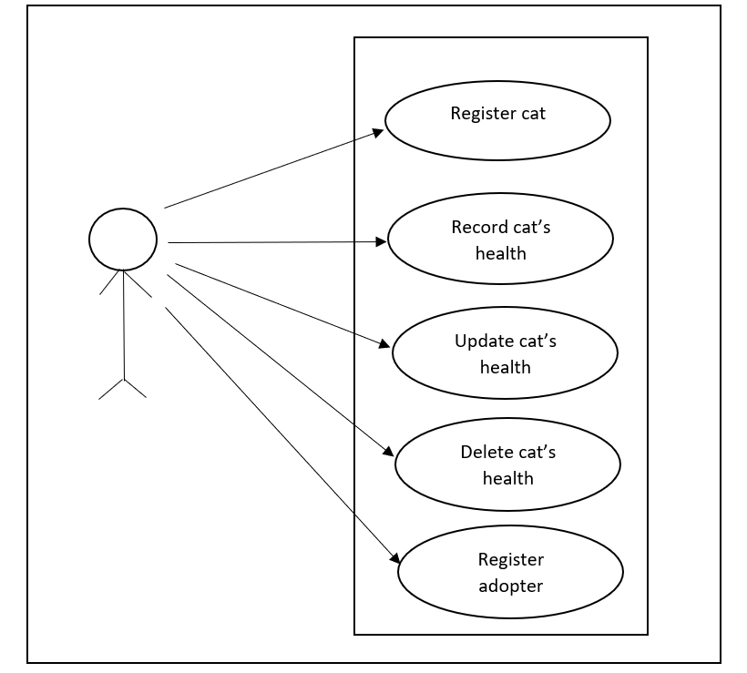

Figure 2.1.1 Use Case Diagram for Cat Management System

**FUNCTIONAL REQUIREMENTS**

|  |  |  |
| --- | --- | --- |
| **Name** | **Descriptions** | **Functions** |
| Register cat | This page enables the administrator to register cat’s information details. | Allow administrator to register cat’s information details. |
| Record health | This page displays the cat’s health record. | Allow administrator to record cat’s health. |
| Update health | This page enables the administrator to update cat’s health. | Allow administrator to update cat’s health. |
| Delete health | This page enables the administrator to delete cat’s health. | Allow administrator to delete cat’s health. |
| Register adopter | This page is for the adopter’s information details registration. | Allow administrator to register adopter’s  information details. |

**FLOWCHART DIAGRAM**

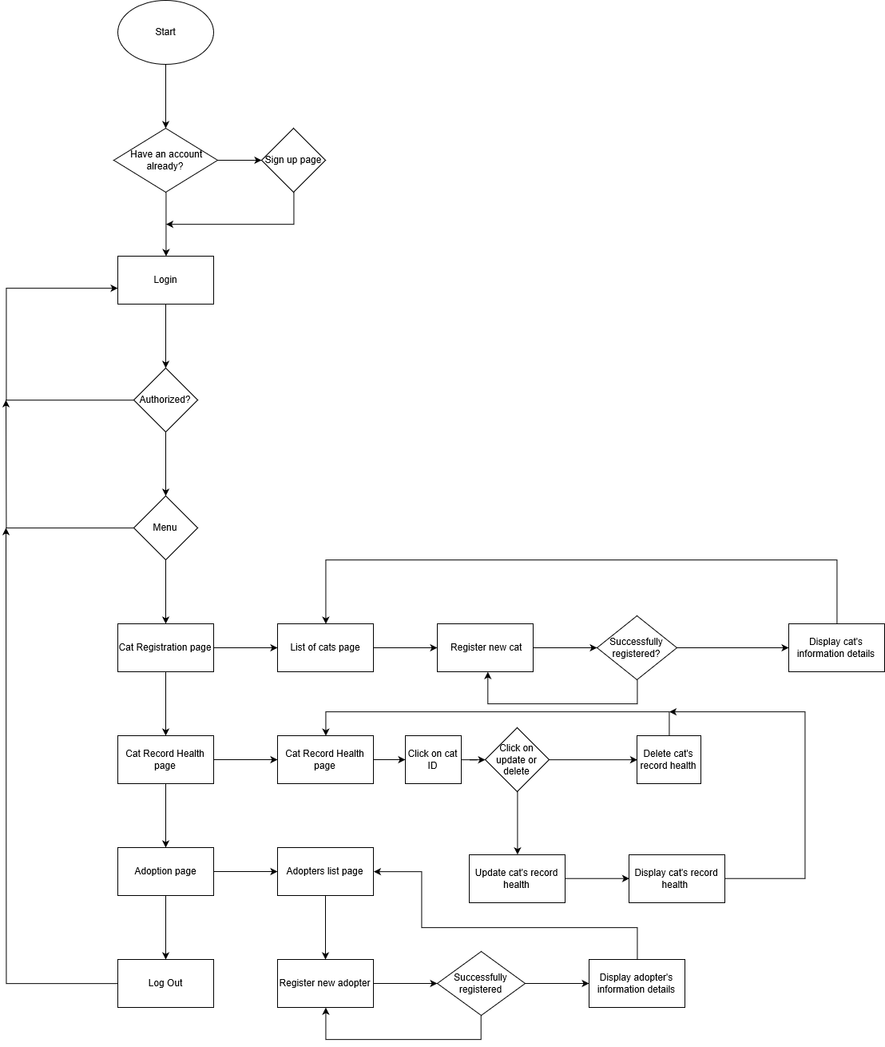

Figure 2.1.2 Flow Chart Diagram for Cat Management System

**3.2 Development**

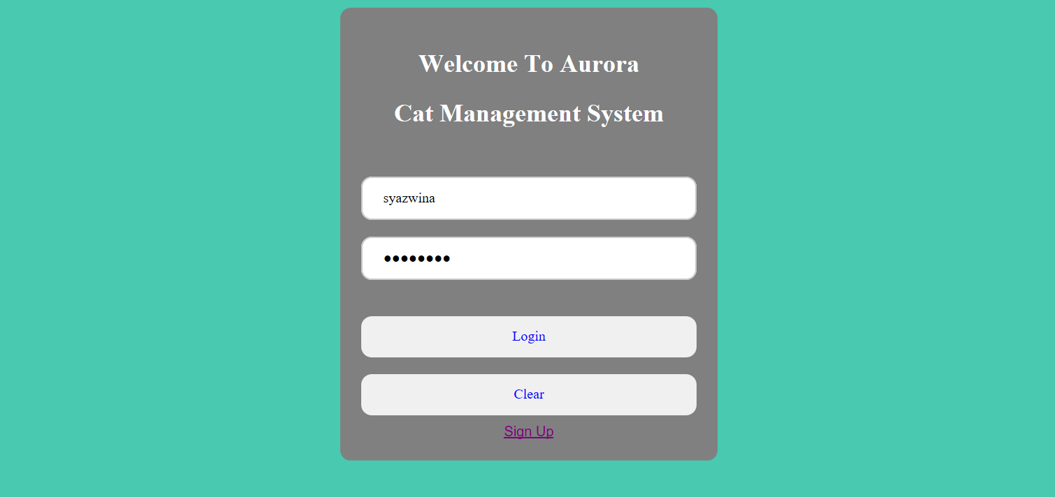

Figure 3.2.1 Log In page

In this page, only administer that already sign up can log in to this system. If the username and password entered is wrong, the administer cannot log in and the invalid login error will be shown.

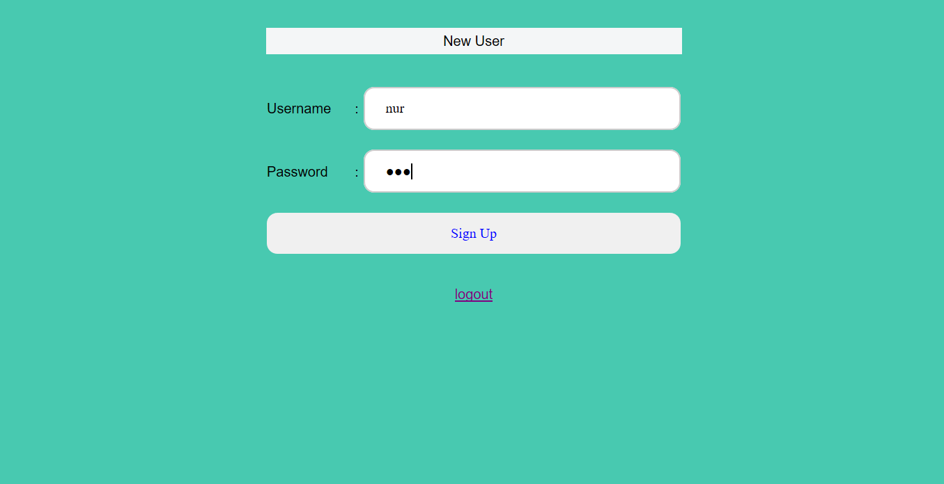

Figure 3.2.2 Sign Up page

In this page, it will enable a new user to sign up.

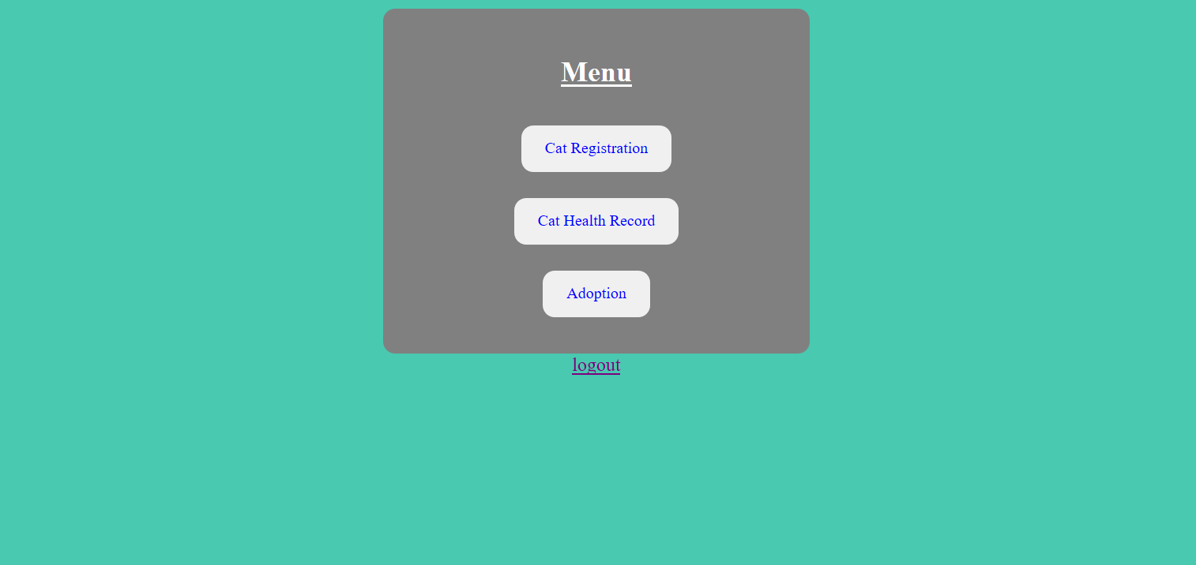

Figure 3.2.3 Main page of the system

In the main page, there are three buttons which have their own functionality:

Cat Registration → Button that will navigate admin to the cat registration page

Cat Health Record → Button that will enable the admin to update and delete the health record of the chosen cat

Adoption → Button that will direct administrator to the adopter registration if there is any adopter that want to adopt the cat

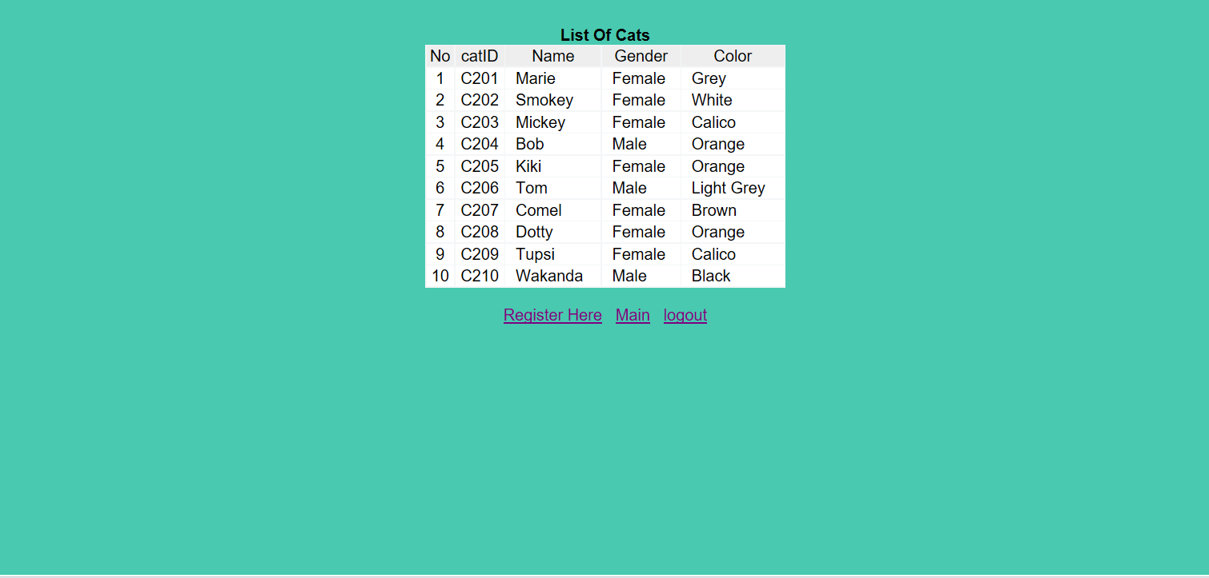

Figure 3.2.4 List of Cats page

In this page, the list of cats with information details such as cat ID, cat name, gender and color is shown.

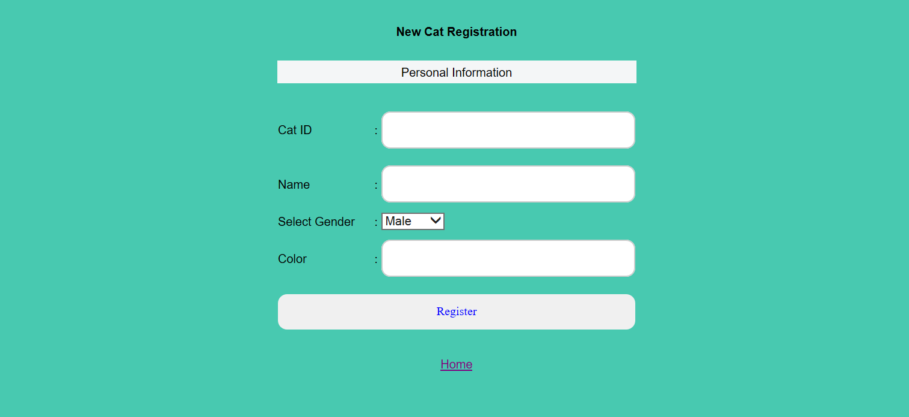

Figure 3.2.5 Cat Registration page

In this cat registration page, administrator needs to fill up all the required information regarding the new cat such as the name of the cat, the cat ID, select the gender of the cat and the color of the cat. If administrator fill in the existing cat ID, the new registration will not successfully been registered.

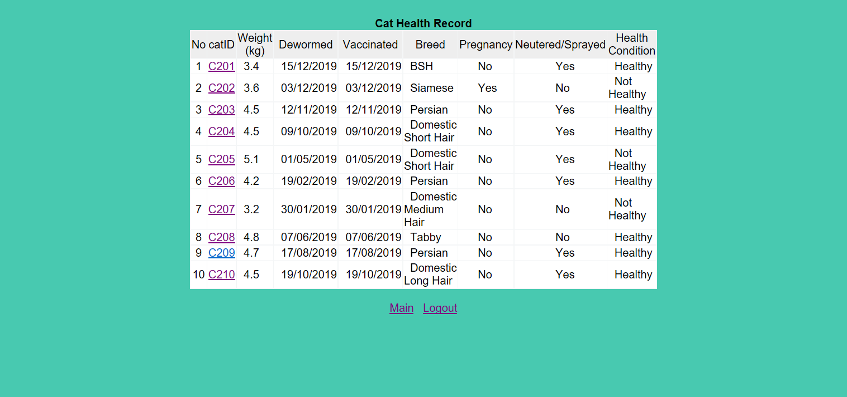

Figure 3.2.6 Cat Health Record page

In this page, the cat’s health record with information details such as cat ID, weight, last date of dewormed, last date of vaccinated, breed, pregnancy, neutered and health condition is shown.

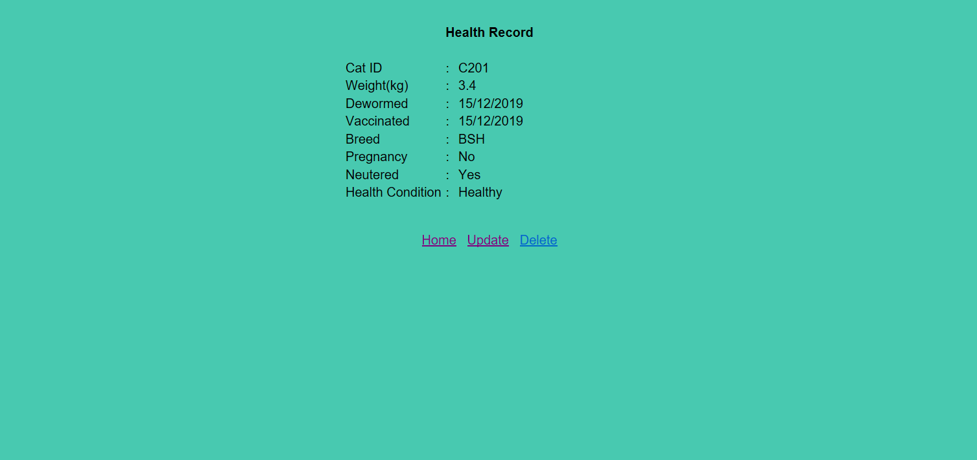

Figure 3.2.7 Health Record page

In this page, the administrator will be able to update and delete the cat’s health record.

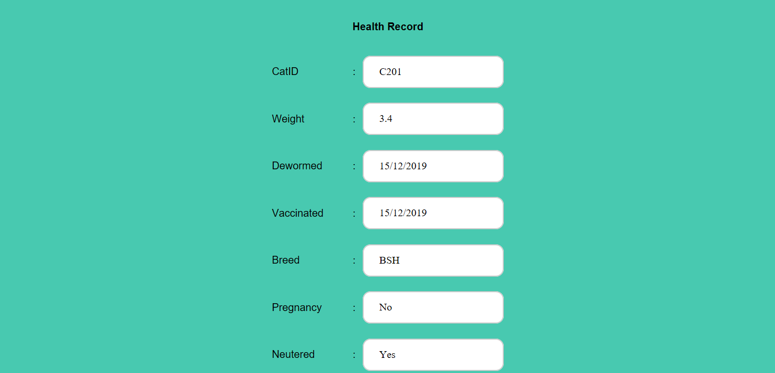



Figure 3.2.8 Health Record Updating page

In this page, the administrator will be able to update for cat’s health by clicking update button. The administrator needs to fill up all the information needed and click update button to save the information.

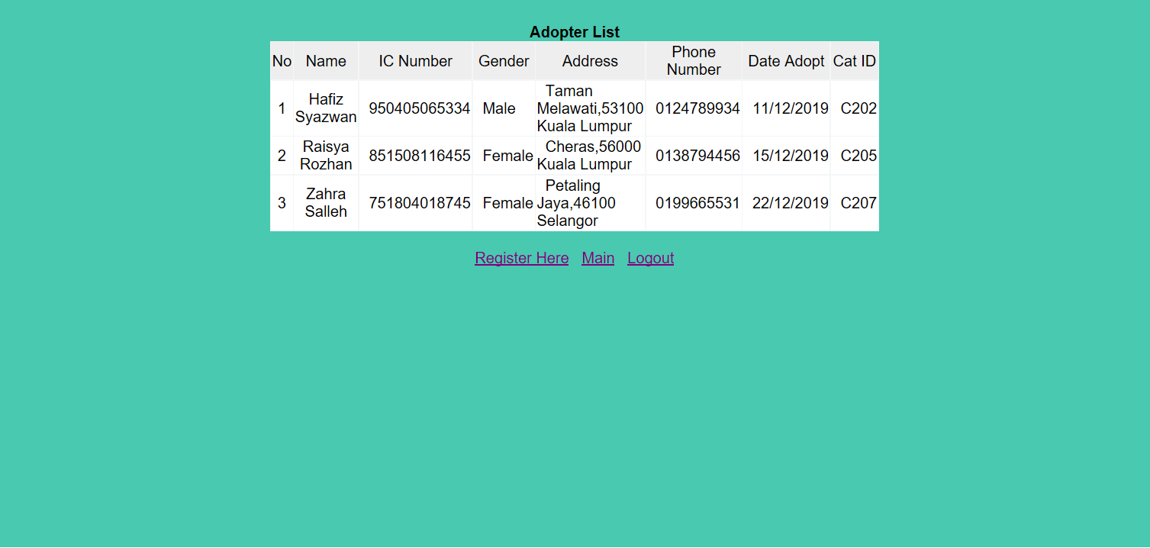

Figure 3.2.9 Adopter List page

In this page, the list of adopters with information details such as name, IC number, gender, address, phone number, date of adopt and cat ID is shown. Cat ID represents which cat the adopter chose to adopt.

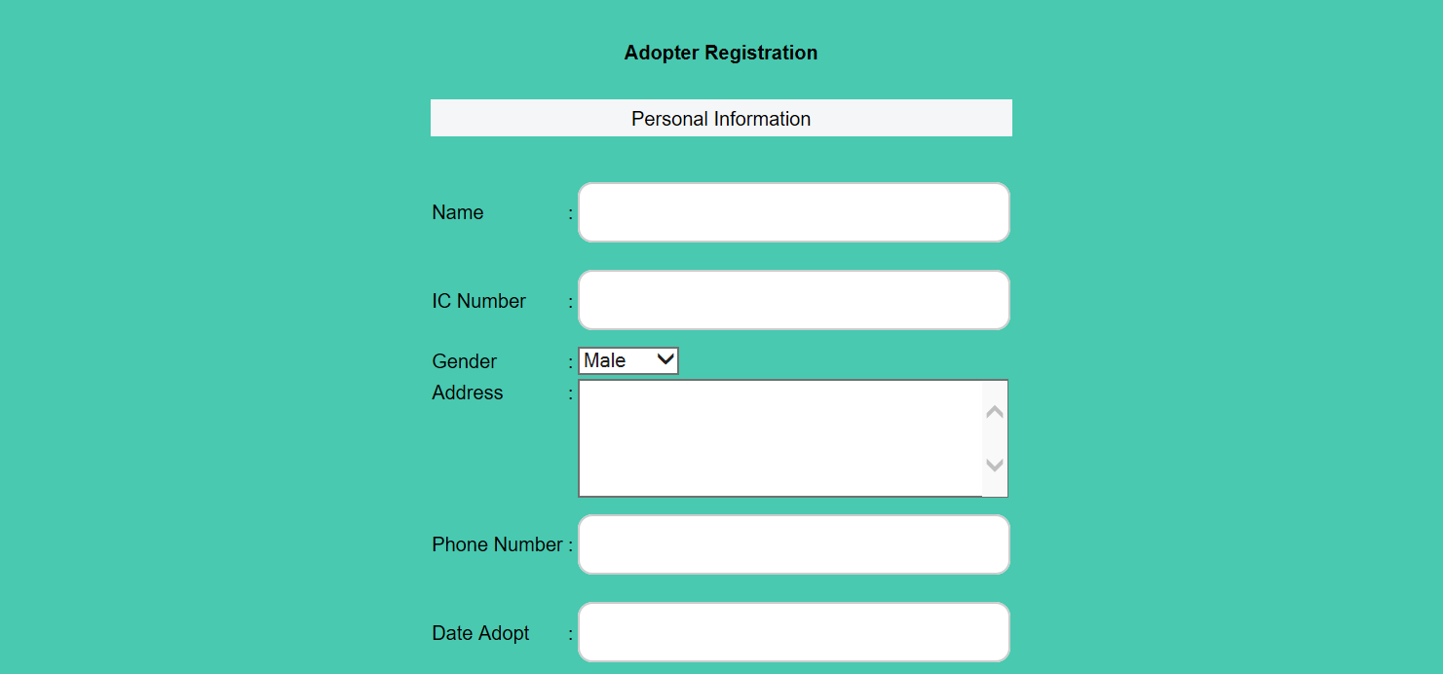



Figure 3.2.10 Adopter Registration page

If a person wants to adopt a cat, the administrator needs to register the person first. In order to do this task, the admin must go to this Adoption page in which the registration of the adopter take place. The information of the registered adopter will be saved by clicking the Submit button.

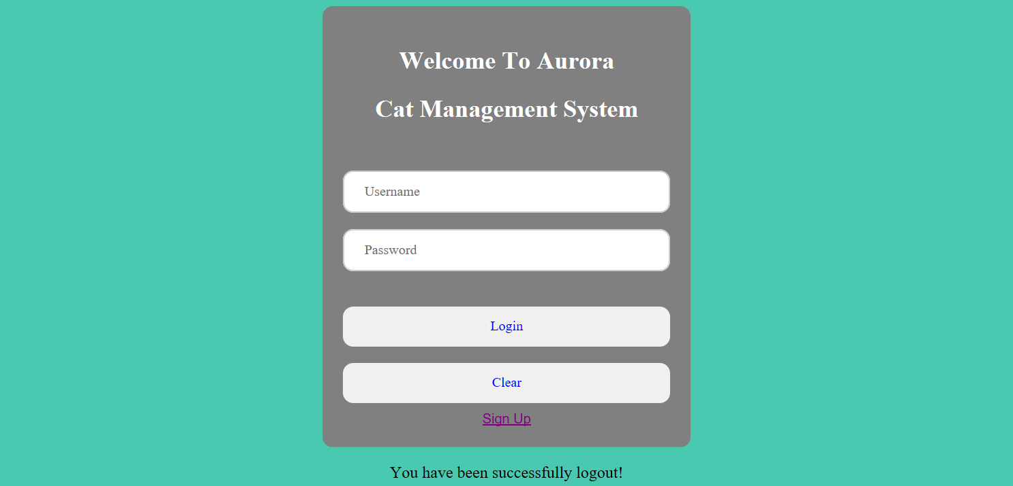

Figure 3.2.11 Log Out page

Log out button is a button that will direct the administrator to the log in page.

1. **Conclusion**

As a conclusion, executing Aurora Cat Management System, the management cat data procedure has been simplified. Previously, administrator have to manage cat data manually whereas the currently developed system offers an efficient way to perform these operations. The administrator can access cat management information system website online through phone and laptop and register the information needed and manage cat data.

The primary objective of my research and development, I am aiming this year is to build a rescue shelter for IIUM stray cats with the objectives to rescue, treat (if needed), neutered and find adopters for the cats.

This system will ease the administrator to register cat’s information details, record cat’s health, update cat’s heath and register adopter’s information details. Administrator can also find it easy to do all this task anytime and anywhere. Besides, we also can reduce unnecessary paperwork in maintaining cat’s information. It also provides easy, accurate, unambiguous and faster data access.

**References**

1) Liang, Y. D. (2015). Introduction to Java programming. Boston: Pearson.

2) MVC in JSP. Retrieved 12 December 2019 from

https://www.javatpoint.com/MVC-in-jsp

3) Pet Finder. Retrieved 12 December 2019 from

<https://www.petfinder.my/listings.php?page=6&sorttype=2&sortage=&sortadopt=0&sortfield=&sortbreed1=&sortbreed2=&sortstate=41326&sortquery>=

**Appendix**

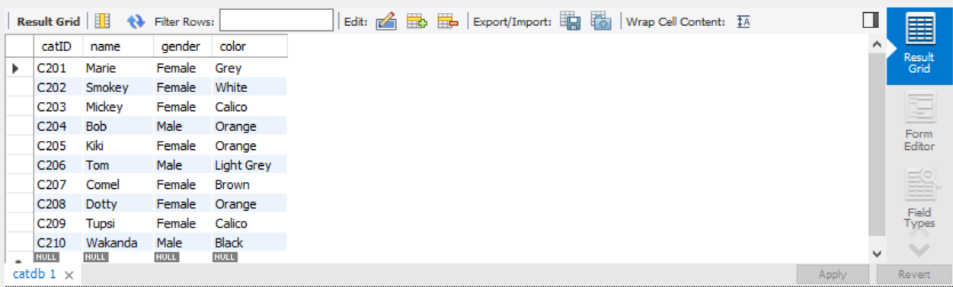

List of Cats

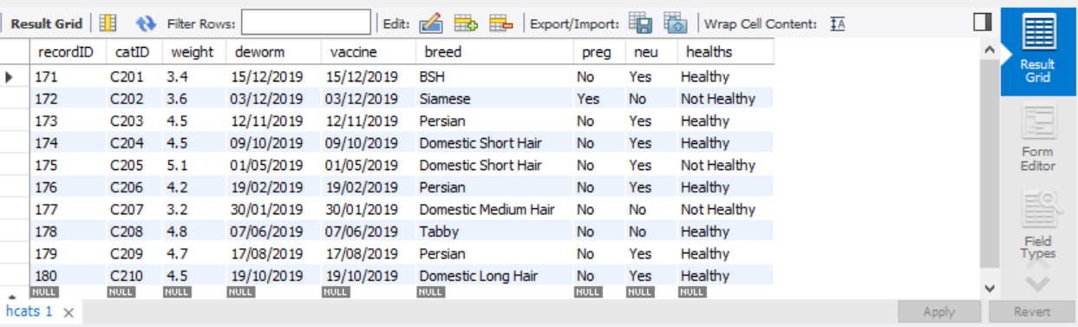

Cat’s Health Record

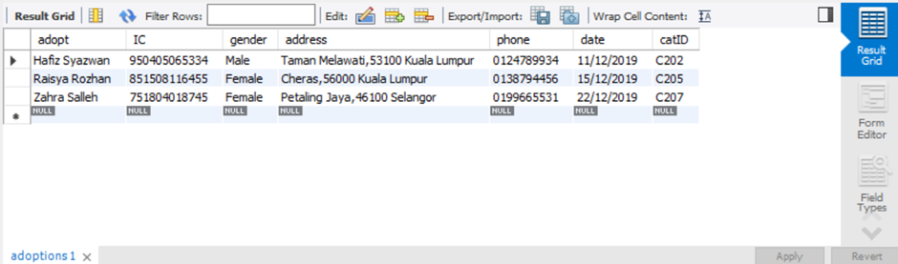

Adopters List